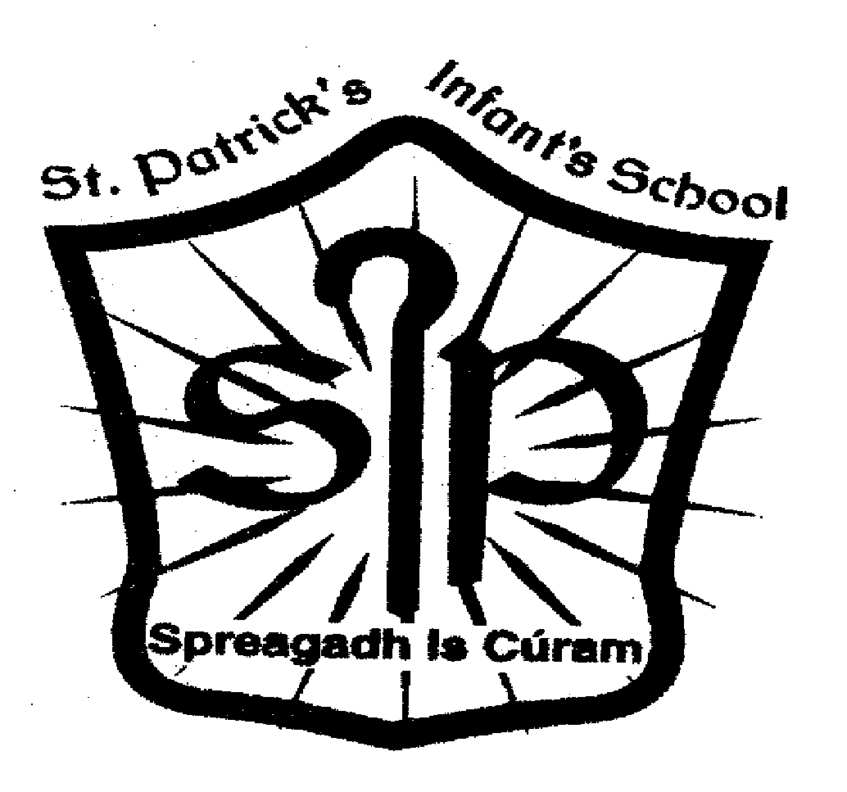 Booklist for Senior Infants 2021 - 2022

You may purchase all books listed below for your child online.

For your convenience, this booklist is uploaded to the website of our local bookseller High Street Books. If you wish to use this facility go to www.hsb.ie and select Saint Patrick’s Infants. Choose Senior Infants. Add all items to the cart. Alternatively you could phone the shop and order the books.

You may also purchase books online from different websites such as www.schoolbooksdirect.ie www.schoolbooks.ie www.schoolbooksireland.ie www.easonschoolbooks.com www.theshelf.ie www.schoolbooksonline.ie

- Busy at Maths Pack: Contains Pupil Book and Home-School Links Book (Senior Infants) – CJ Fallon €13.15
- Explore with me: Contains Book and My Little Book of Home-School Links Posters (Senior Infants) – EDCO €10.50
- Spell Well (Senior Infants) - CJ Fallon €8.50
- Ready to Write B1 – Handwriting (Senior Infants) – EDCO €7.30

Total cost of activity books: €39.45 (Please note that prices are accurate at the time of print)

There is a Book Rental Scheme in operation in our school. English readers and library books are covered under this scheme.
Please write your child’s name on the inner labels of the uniform and tracksuit jumpers.

Please contact Anne O’Connell (Principal) and complete the attached form if you qualify for assistance under the “Grant Scheme for Needy Pupils”.

Please put the amount of €30.00 in an envelope and ask your child to hand it to the Class Teacher to cover the cost of all of the other items listed below. These items will be supplied by the school.
Thank you.

The following will also be supplied by the school:
Arts and Crafts materials: €10.00
Photocopying: €10.00
Book Rental Charge: €5.00
Assessment booklets: €3.00
Interactive resources: Irish and Religious Education programmes €2.00
€30.00

Grant Scheme For School Books for Needy Pupils

If you are:

- Dependant mainly on Social Welfare
- On low income
- Experiencing Financial Hardship

You may qualify for the above scheme. Please return the completed form below to the school office.

…………………………………………………………………………………………

Child’s Name: _____________________________

Child’s Class: _____________________________

Please give reason for application:

_____________________________________________________________________

_____________________________________________________________________

_____________________________________________________________________

Parents Name: _____________________________

Signature: _________________________________

Please return this form to the school office for the attention of Anne O’Connell (Principal).

